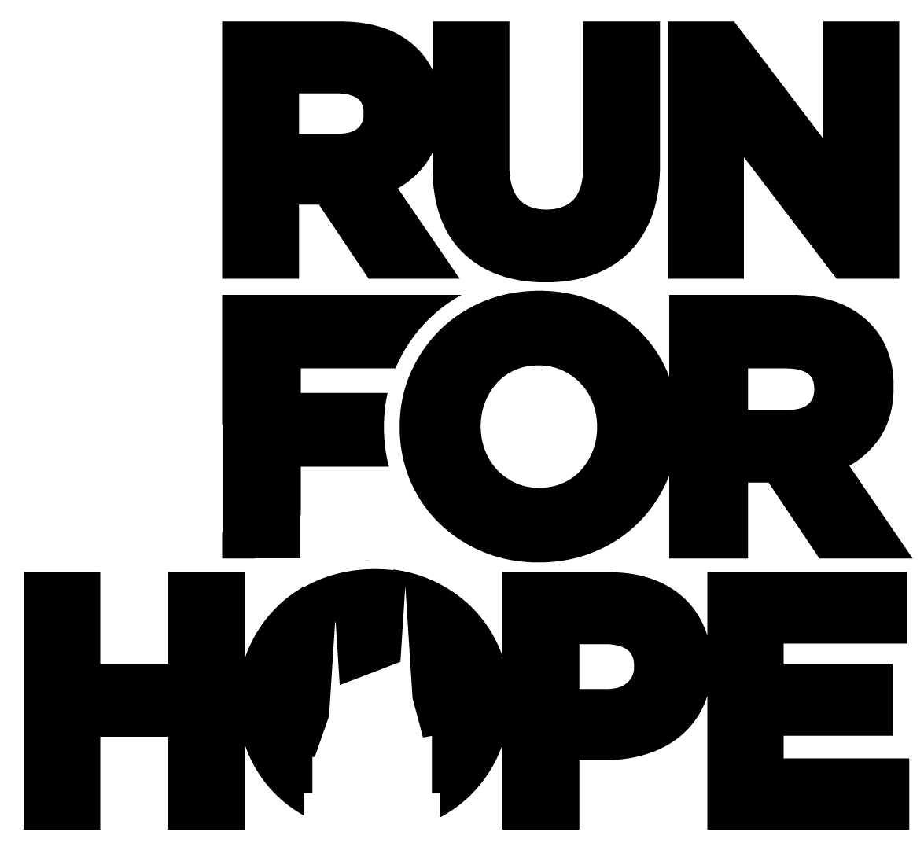

Dear [insert recipient’s name],

On April 25, 2020, I will be [running / walking] the Nashville [5K / 1⁄2 Marathon / Full Marathon] in Nashville, Tennessee. Something more than the promise of a smaller pant size is motivating me to train for this event!

I am participating with Run for Hope to benefit New Hope Academy, an amazing school located south of Nashville in Franklin, Tennessee.

New Hope Academy is breaking the cycle of generational poverty by reserving 50 percent of its seats for low-income families, believing a top-notch, Christ-centered education will launch them into a bright future. New Hope intentionally creates opportunities for students and parents to form relationships across racial, economic and cultural lines. To that end, Run for Hope is committed to bringing the vision of New Hope to the wider community and beyond. We are on a mission to turn racial division, class segregation and spiritual poverty into community, possibility and vision.

I have committed to raise [$xxx amount] as part of Run for Hope. Will you be one of 26 people to donate [use $19 if your goal is $500; use $39 if your goal is $1000; use $78 if your goal is $2000] toward that goal? I encourage you to donate online at my personal fundraising webpage: [enter your FirstGiving.com URL here]. All donations are 100% tax deductible.

Thank you for your contribution!

With Gratitude,

[insert your name]

